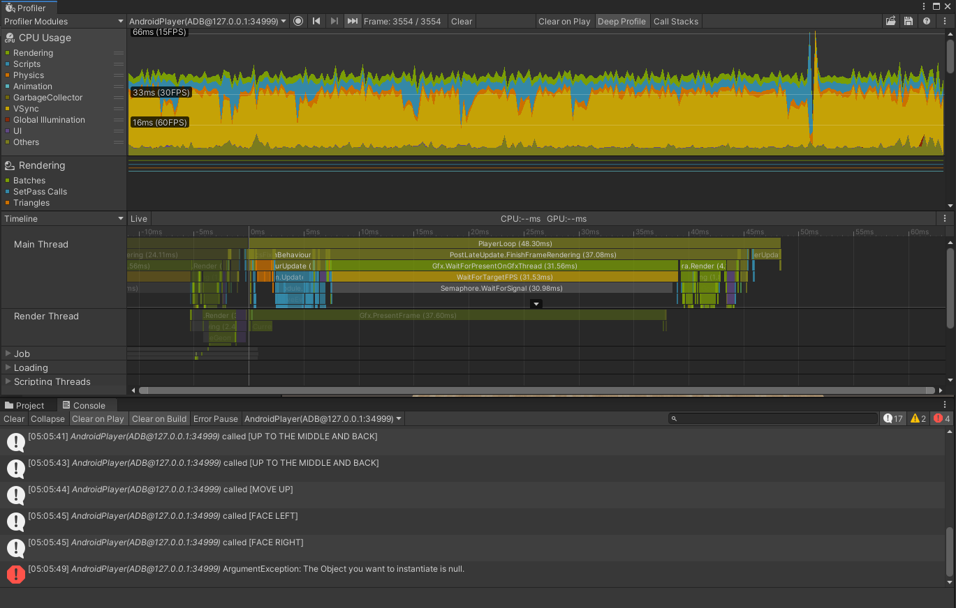

This is my first profile of a small build, where the only thing implemented is swipe controls. Everything happens in under 12ms, so we’re at well over 60fps. If only I could keep it at that. We’ll see! Performing a swipe does put it right up to the edge of 60fps. In the next image you can see the infamous garbage collection going on in the red line labeled 6.0KB. And the big spike is the error generated because I haven’t implemented the DOWN RIGHT swipe yet, which will be “Reset the square.”

